How to check if ODBC drivers need to be installed.

1. Open control Panel

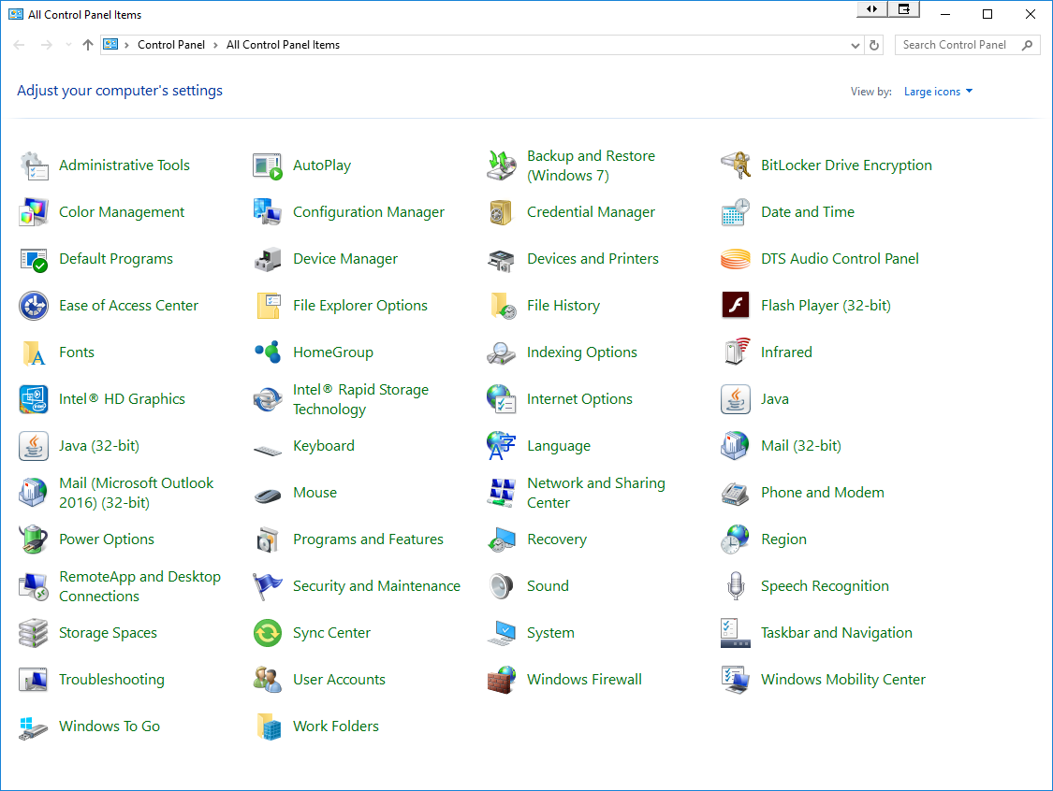

1. Select Administrative Tools
2. Select ODBC Data Sources (depending on operating system you might have either 32 or 64 bit or both)

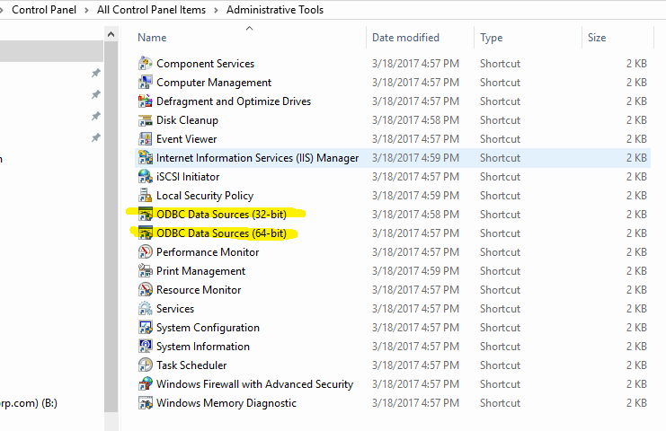

1. Select 32bit ODBC Data Source, you will be asked to insert your admin password.

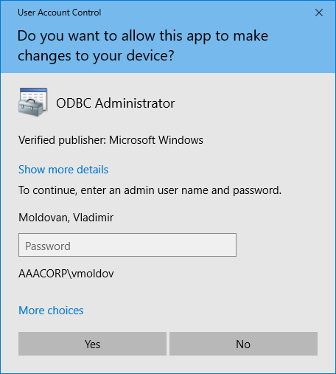

1. After you enter your password, the following window will open

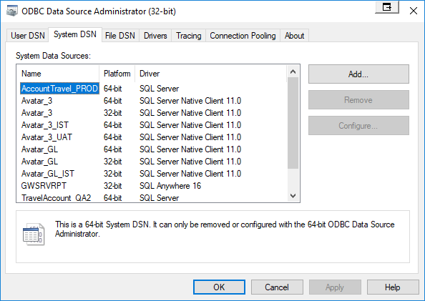

1. Select System DSN Tab page and then click on [Add…] button
2. If you only have SQL Server available, then you’ll need to get SQL Server Native Client installed.

